Anisha Aggarwal

CS 161

Homework 1

**Draw a flowchart the rock paper scissors game from Session #1**

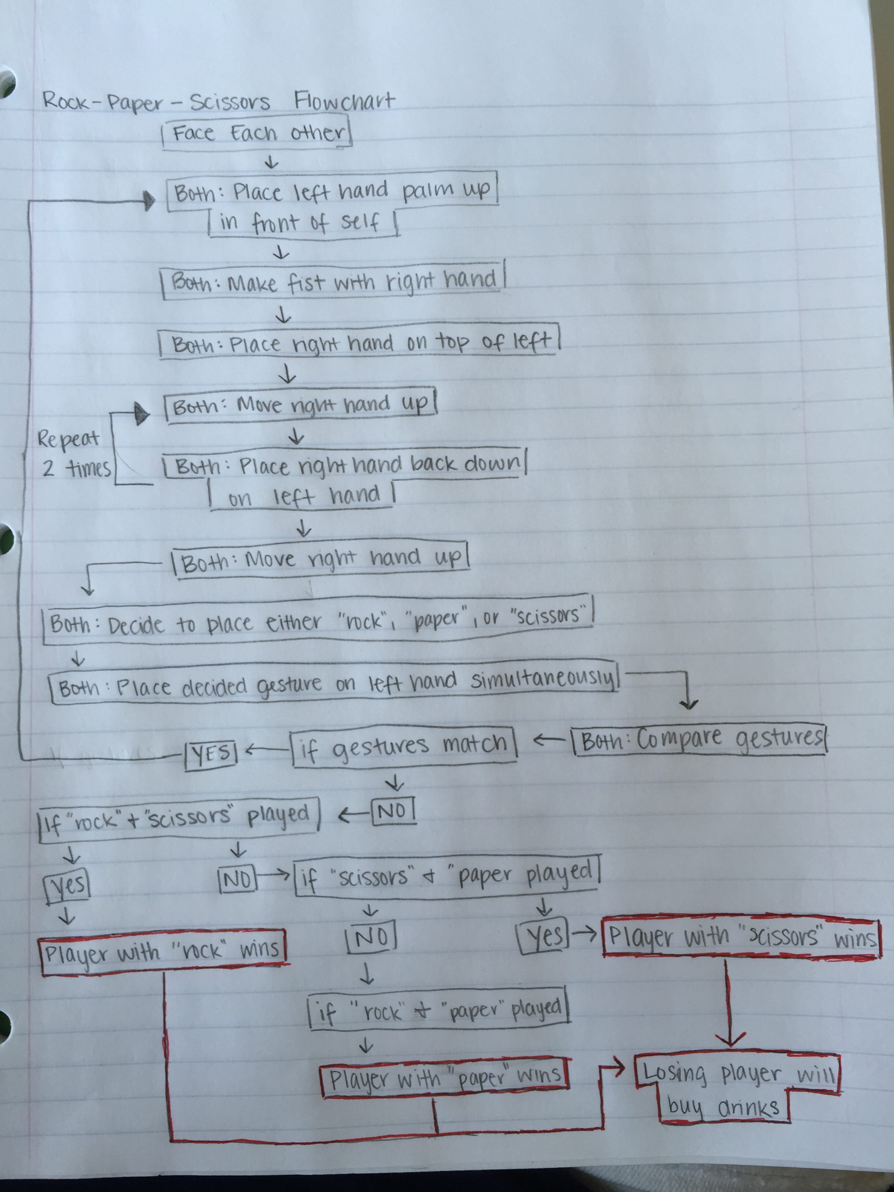

**Compare the SLiK program to the C++ code that was generated. Discuss the differences and similarities.**

Differences: One of the differences I noticed was that in a SLiK program we had to start and end the program by writing out “start” and “stop” where as in C++ the program is all written within brackets {}. Another difference is that in C++ at the end of each line there must be a semicolon whereas in SLiK there is no semicolon necessary.

Similarities: They both read comments when there is a “//” before the comment.

**What changes did you make to the SLiK program? What kind of errors did you encounter?**

I added in another question asking why the person is taking the class. I forgot to add in the string name at the top before inputting the string into the program. This resulted in an error because it was not able to identify what that string was.

**What changes did you make to the C++ program that was entered? What kind of errors did you encounter?**

I tried making comments using “/*” and when I ran the program nothing appeared. I realized that it was because I never finished the line with “*/” again. This had caused my entire program to be commented out rather than just the one line like the “//” did.

**Chapter 1 Review Questions (4 – 13)**

4. A programming language’s rules are its syntax.

5. The most important task of a compiler or interpreter is to translate programming language statements into machine language.

6. Which of the following is temporary, internal storage?

- computer memory

7. Which of the following pairs of steps in the programming process is in the correct order?

d) code the program, translate it into machine language

8. A programmer’s most important task before planning the logic of a program is to understand the problem.

9. The two most commonly used tools for planning a program’s logic are flowcharts and pseudo code.

10. Writing a program in a language such as C++ or Java is known as coding the program.

11. An English-like programming language such as Java or Visual Basic is a high-level programming language.

12. Which of the following is an example of a syntax error?

c) misspelling a programming language word

13. Which of the following is an example of a logical error?

d) all of the above

**Draw a flowchart AND write an algorithm (in English) to find out if you have $25 in your wallet**

